Brainstorm & Idea Prioritization Template

Date | 01 November 2025
Team ID | NM2025TMID07694
Project Name | Educational Organisation Using ServiceNow
Maximum Marks | 4 Marks

Brainstorm & Idea Prioritization:
Step-1: Team Gathering, Collaboration and Select the Problem Statement
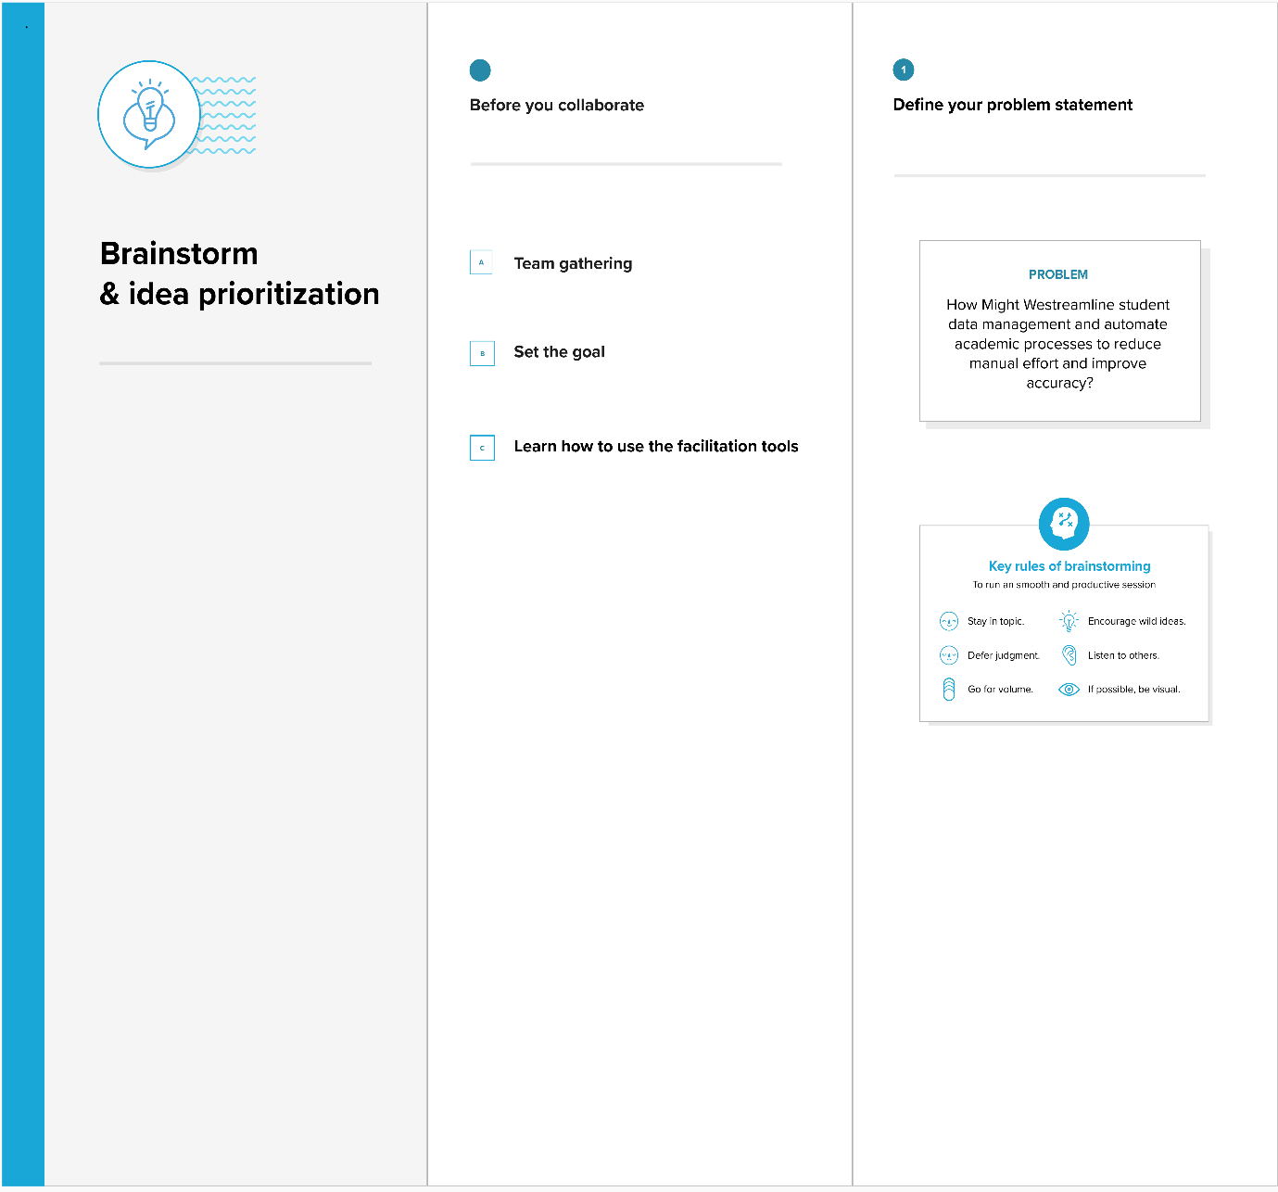

Step-2: Brainstorm, Idea Listing and Grouping
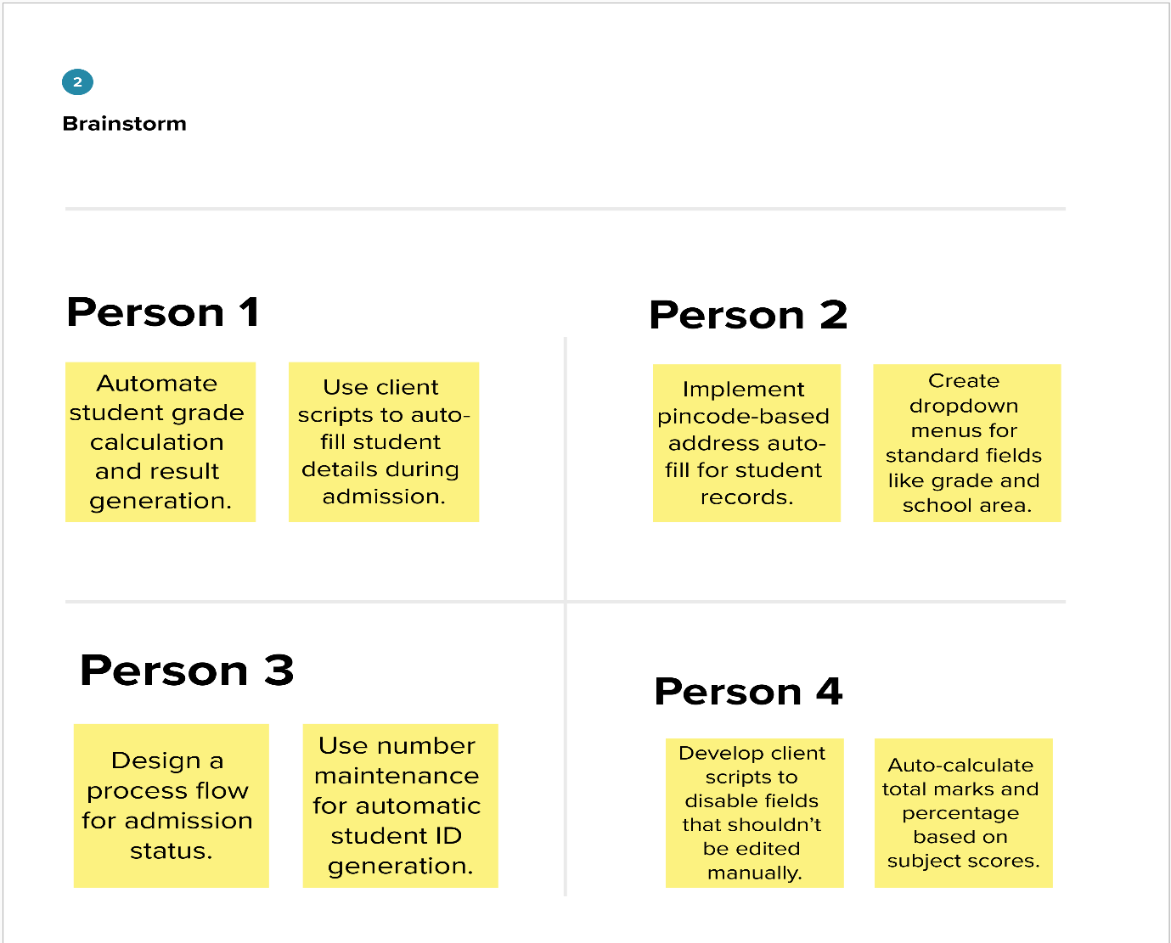
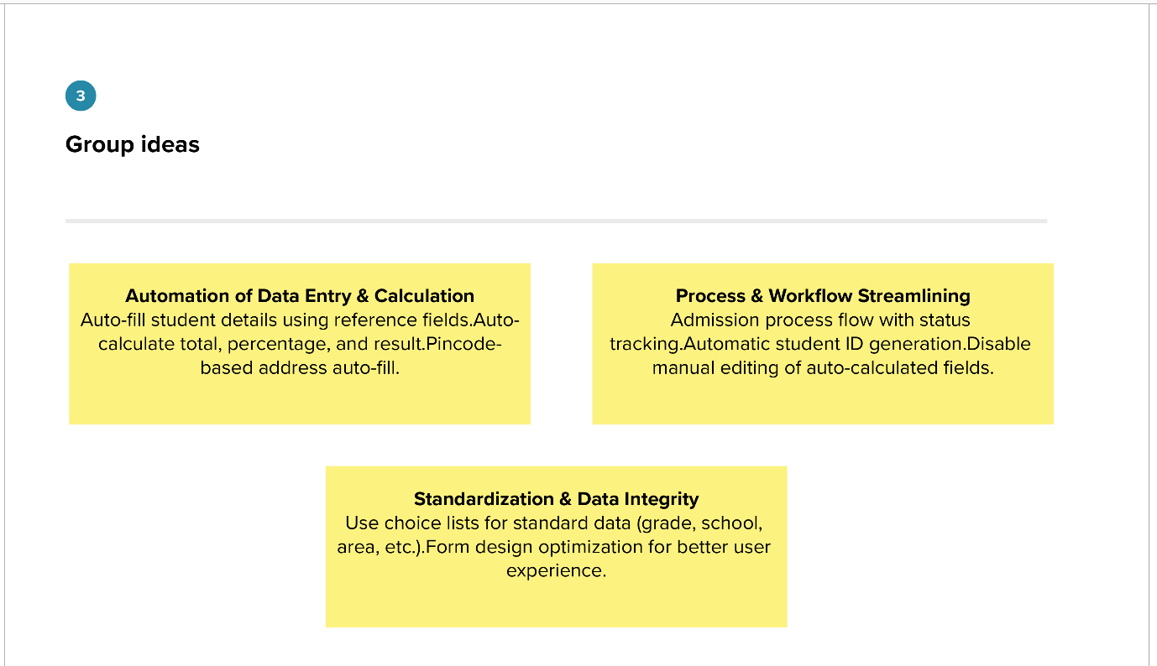

Step-3: Idea Prioritization
